Kuala Lumpur, Malaysia, Release: June 16th 2023.

*For Immediate Release*

**The Timeless Charm of Jazz Pop Resurfaces in Lyia Meta’s “Memorabilia”**

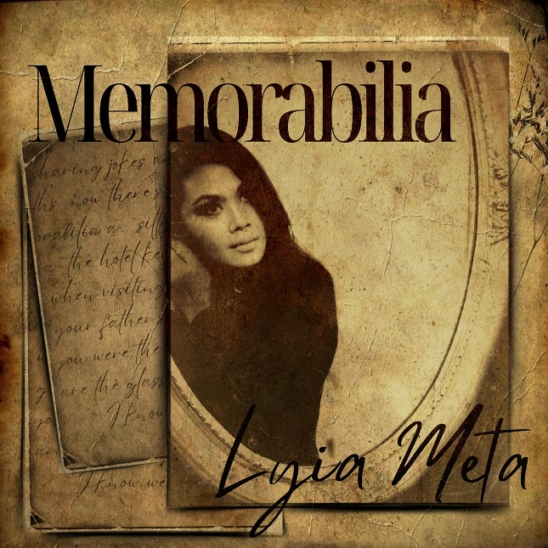

**Kuala Lumpur, Malaysia —The allure of Jazz Pop, with its lush strings and rich melodies, has captivated listeners for generations. Lyia Meta’s latest release, “Memorabilia,” is a stunning example of this timeless genre, capturing the romance of yesteryear with a contemporary twist.**

**Penned by songwriter Mary Ann Heimann and produced by Bob McGilpin, “Memorabilia” is a collaboration that seamlessly blends the iconic sounds of the Jazz Pop era with Lyia Meta’s unique vocal stylings. Lyia’s contralto vocals resonate with a depth and richness that pay homage to the past while embracing the present.**

**“Memorabilia” is a journey through time, evoking memories and emotions that are both nostalgic and current. This release showcases Lyia Meta’s ability to capture the essence of an era while infusing it with her own modern flair.**

**Listeners can experience the magic of “Memorabilia” on** [**Spotify**](https://open.spotify.com/track/3k7cBaCrcsP2ONNm0HyCsj?si=moqKjgAcT8G5IxOv9eEd2g&context=spotify%3Atrack%3A3k7cBaCrcsP2ONNm0HyCsj) **, available starting April 26th, 2024.**

**For more information or to schedule an interview with Lyia Meta, please contact** [**l.nunismeta@gmail.com**](mailto:l.nunismeta@gmail.com)

**About Lyia Meta**

**Lyia Meta is a multi-award-winning singer, songwriter, and visual artist known for her rare contralto vocal range. Drawing comparisons to blues-pop legends Nina Simone and Amy Winehouse, Lyia has carved her own path in the music world, earning acclaim in genres ranging from blues and jazz to pop and metal. Her latest release, “Memorabilia,” is a testament to her versatility and artistry.**

Website: <https://www.lyiameta.com/>

<https://linktr.ee/LyiaMeta>

Sales Outlets: Amazon, iTunes, Deezer,

Apple Music and all major platforms.

